**CHRIST (Deemed to be University)**

**Department of Computer Science**

**MSc – Artificial Intelligence and Machine Learning**

**Name:** Syed Mohammed Luqmaan (2448552)

**Course:** Java Lab

**Lab Experiment:** 5

**DESCRIPTION:**

**5.a.**

**This program demonstrates the use of interfaces in Java by defining a BankInterface with methods getBalance and getInterestRate. Three bank classes (BankA, BankB, BankC) implement the interface, each with specific balances and interest rates. The main class creates objects of these banks and prints their balances and interest rates. It shows how different implementations can follow the same interface structure.**

**Code screenshots:**

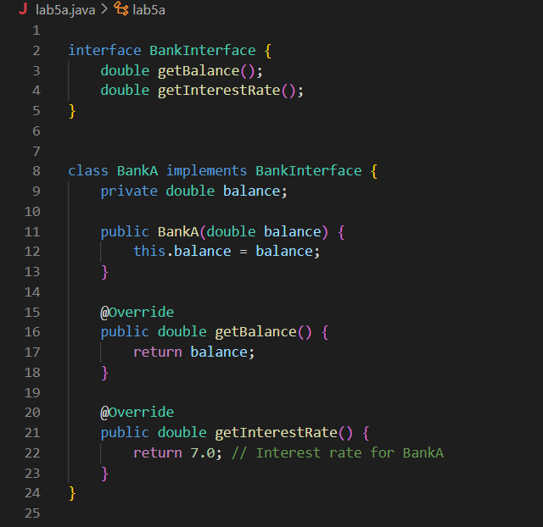

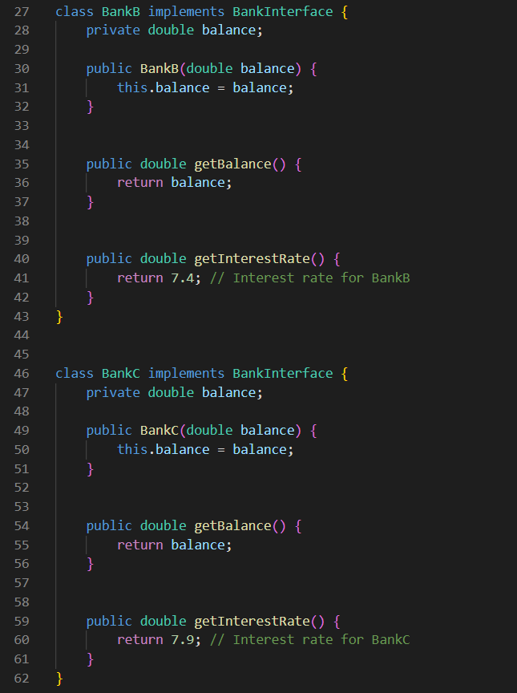

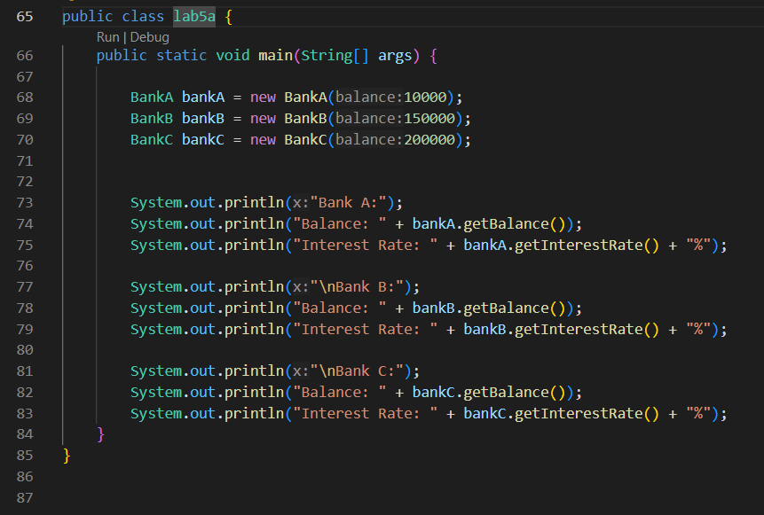

**Output:**

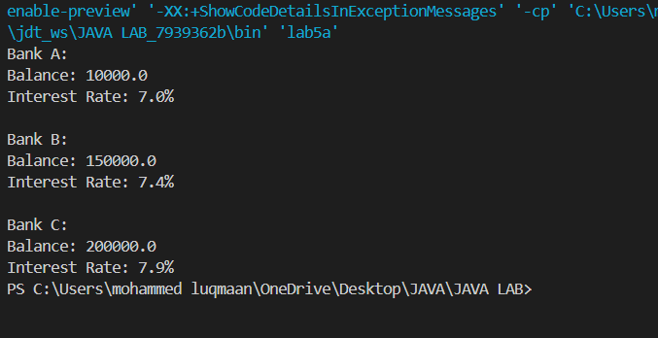

**5.b.**